Template for Preparing Manuscript on the JPK Wallacea
(Title should be concise and informative. The title should not exceed 20 words; Cambria at 16-point font size)

First Author^{1*}, Second Author² Third Author²
(The author’s full name (s) written without title and position; Cambria at 10-point font size)
¹First affiliation department, institution, postal address, City, postal code, Country
²Second affiliation department, institution, postal address, City, postal code, Country
*Corresponding Author E-mail: author@author.com
(Affiliation and corresponding author; Cambria at 9-point font size)

Abstract
The abstract should not longer than 250 words. It should be typed in Cambria at 10-point font size with single spacing. It should state the research background, the purpose of the research, methods, the principal results, and major conclusions. The abstract is written without reference, without footnotes or citations, without acronyms.
Keywords: List three to five keywords alphabetically that describe the nature of the research. These keywords should not include words in the title

INTRODUCTION (SECTION)
JPK Wallacea is a scientific publication of research results in conservation of biological resources, including sustainable management of biological resources, social aspects, and policies in conservation. JPK Wallacea published by the Forest Conservation Study Program, Faculty of Forestry, Hasanuddin University.
Every author is advised to follow the writing instructions as described in the Author Guidelines to facilitate the editing process. The format style of this template has been adjusted to the specifications written in the JPK Wallacea Author Guidelines so that this file can be used as a template for writing the manuscript.
Provide research background that clearly explains problems, research types, research needs, state of the art, and the objectives of the work. Background should be written in an inverted pyramid structure. Introduction containing scientific hypothesis or prediction are highly valued.
Citation example:
Tropical rainforests, which are home to world diversity, have been threatened in line with the significant increase in population for several last decades (Morris, 2010). Unlike pioneer tree species that usually produce small fruit with thin seeds, climax tree species that produce large fleshy fruits with large recalcitrant seeds should take longer to grow and ripen their fruits (Rungrojtrakool et al., 2021). This is because such fruits fall at the onset of the mid-wet season (Nanda et al., 2014), and their recalcitrant seeds that last only a short time (Berjak & Pammenter, 2017). Therefore, apart from understanding the level of litter productivity, knowing its species composition and tree components is also crucial (Berg & Meentemeyer, 2001).

METHODS (SECTION)
The methods must explain in detail the research procedure to convince the reader to trust the research results and allow other researchers to follow them. Methods that are already standard can be summarized by mentioning the reference source. Any modifications to standard methods should be explained. Formulas and equations should be written to validate the research results. Provide sufficient details of the data-collection procedure to allow the work to be reproduced by another researcher.

Manuscript Format (Sub Section)
The manuscript should be typed in A4 paper (210 mm x 297 mm) with 1.5 spacing using common word processor software such as Microsoft Office Word. The margin for all sides is 2.5 cm and consists of not more than 7500 words excluding references. The manuscript should be typed in Tahoma at 11-point font size. The title should be concise and informative. It contains the major keyword and must describe the scope of the research. The title should not more than 20 words. The full name of the author(s) (without title and position) and its respecting affiliation(s) should be typed immediately after the title using Tahoma at 11-point font size. The affiliation(s) should be consisting of the name of their respected institution(s), and address(es). The authors should be the person who substantially contribute to the work. Authorship credit should be based only on substantial contributions to research conception and design, analysis of data, and drafting of the article, etc. Keywords; Immediately after the abstract, provide a maximum of 5 keywords.

Making Headings (Sub Section)
The journal template adheres to heading system starting from SECTION (INTRODUCTION, MATERIALS AND METHODS, RESULTS, DISCUSSSION), Sub Section, Sub-sub section. When possible authors are suggested to format the heading following the heading system of Microsoft Office. To do so, authors just have to click on the “Format Painter” to adjust your needs in compiling section by section (Figure 1): (1) click on the Chapter section where the format will be imitated (left with red font), (2) click the pointer format, (3) point out the cursor to the place where the chapters will be created or arranged, then click the Chapter.
Among the benefits of making headings is automatically creating a Table of Contents and making it easier to create a bookmark after the file is converted to pdf.

Figure 1. Position the format poiters in MS. Word 2013

Figures and tables should not be submitted in separate files. If the article is accepted, authors will be asked to provide the source files of the figures. Each figure should be supplied in a separate electronic file. All figures should be cited in the manuscript in consecutive order. Figures should be supplied in either vector art formats (Illustrator, EPS, WMF, FreeHand, CorelDraw, PowerPoint, Excel, etc.) or bitmap formats (Photoshop, TIFF, GIF, JPEG, etc.). Bitmap images should be of 300 dpi resolution at least unless the resolution is intentionally set to a lower level for scientific reasons. If a bitmap image has labels, the image and labels should be embedded in separate layers. Figures should be referred to as Figure 1, Figures 2, 3-5, using Arabic numerals. Ensure that all figures, and schemes are cited in the text in numerical order. Figure captions should be 11-point Cambria and non-italic. Initially capitalize only the first word of the caption. The figure caption should be below the figure and should be fully justified to the right and left above the table.

Math formula equations (Sub-sub caption)
Mathematical equations must be written clearly, neatly, and be accompanied by the required information and must be separated from the surrounding text. The equation’s number should be written and placed after the equation. The equation is written in Equation format (not as an image).
Example: Net Present Value (NPV)
NPV= t=1 nBt-Ct1+it (1)
Remarks:
Bt = Gross revenues at year t (Indonesian rupiah)
Ct = Gross cost of farming at year t (Indonesian rupiah)
n = Economic age (year)
i = Discount rate (%)
t = Time

Inclusion of maps (Sub-sub Section)
The research map is afigure and therefore it should be explained in the main text. The map should be in a good resolution (at least 300 dpi). Maps should be completed with scale, legend and coordinates (latitude and longitude). Use a bar scale instead of numeric scale to anticipate how the map scale changes when the image is scale down.

Stages in Research (Research Design) (Sub Section)
The data collection procedure should be brief but informative for readers who wish to repeat the research reported.

Data Analysis (Sub Section)
Data analysis procedures must be written clearly. All statistical analyses performed (e.g., Anova, linear model, post-hoc test, etc.) should be explained in this subchapter. If you followed a procedure developed from another paper, cite the source and provide a general description of the method. Any software used (e.g., SAS, SPSS, R, etc.) should be mentioned.

RESULTS (SECTION)
The results only describe the data obtained through the research process. Please ensure that all the data provided in the results section refers to the method. Each data that appears in the results section must have a method or procedure for obtaining this data. Data can be displayed in the form of tables, graphs, charts, photos, maps, or other forms of illustration. The information contained in the text must be independent and complement the data contained in tables or graphs. Nominal that has been stated in the table or graph may not be repeated in the text, because the reader can see it directly in the table or graph. Avoid redundant and repetitive explanations.

Making the Table (Sub Section)
Number the tables consecutively in accordance with their appearance in the text. A comma (,) and a period (.) are used in numbers to show decimal and thousand separators, respectively. The table format does not use vertical lines.
The table must be provided as an editable file, not pasted in as an image, the information contained in the table must be independent and complement, not duplicate, the information contained in the text. Legends and footnotes should be brief but comprehensive and understandable without reference to the text. All abbreviations and symbols must be defined in the footnotes. The symbols *, **, *** must be used for P-values. Statistical measures such as SD or SEM should be identified in the title.

Table 1. Mean abundance of soil macrofauna in three forest communities
Species | Family | Mean Abundance of Macrofauna In Each Forest Community
Species | Family | Karst |  |  | Lowland |  | Pine
Species | Family | Dry | Wet |  | Dry | Wet | Dry | Wet
Odontotermes sp. | Termitidae | 47.9 a | 1.0 b |  | 2.4 a | 1.2 a | 26.9 a | 0.3 b
Odontomachus sp. | Formicidae | 6.8 d | 10.2 d |  | 4.3 d | 9.8 e | 2.8 d | 5.4 d
Solenopsis geminate | Formicidae | 8.9 g | 6.9 g |  | 5.2 g | 8.9 h | 0.3 g | 4.4 h
Eudrilus eugeniae | Eudrilidae | 2.3 j | 6.7 k |  | 3.8 j | 7.3 k | 2.8 j | 5.1 k
Paratre. longicornis | Formicidae | 1.0 m | 2.3 m |  | 1.4 m | 1.6 m | 0.6 m | 1.0 m
Willowsia sp. | Entomobryidae | 0.6 p | 3.4 q |  | 5.0 p | 4.4 p | 1.2 p | 1.2 p
Philoscia sp. | Philosciidae | 1.1 s | 2.0 s |  | 0.1 s | 2.3 t | 0.3 s | 0.7 s
Total in the Forest Soil |  | 68.6 v |  | 32.5 v | 22.2 v | 35.5 w | 34.9 v | 18.1 v
Different letters after the mean abundance value in the rows of each forest community column indicate significant differences between seasons in each forest community (ANOVA with Tukey's HSD method at P < 0.05).

Tables should be cited consecutively in the text. Every table must have a descriptive title and if numerical measurements are given, the units should be included in the column heading. Vertical rules should not be used. Table titles should be 11-point Cambria and non-italic. Table content should be 10 -point Cambria. Initially capitalize only the first word of the caption. Table titles are to be fully justified right and left above the table.

Making the Image (Sub-sub section)
Figures can be in the form of graphical images (line figures), photos, research map or illustrations. Graphical images or line figures and other illustrations should be clear and contrast. Line figures or other illustrations that consist of more than one field should use patterns instead of colors. Please note that line figures are preferably in black and white so that they are legible when printed by readers in black and white.
Every figure should be numbered consecutively in accordance with its appearance in the text. Captions for images should be made briefly, concisely, and clearly. The font used in the image is Tohama, with a size that is proportional to the size of the image and the font in the main text. Photos should be in a high resolution (300 dpi).
The information contained in the figure must be independent and complement, not duplicate, the information contained in the text. As also the tables, figures should be placed after the first mention in the text. For example Fig. 1 and Fig. 2.
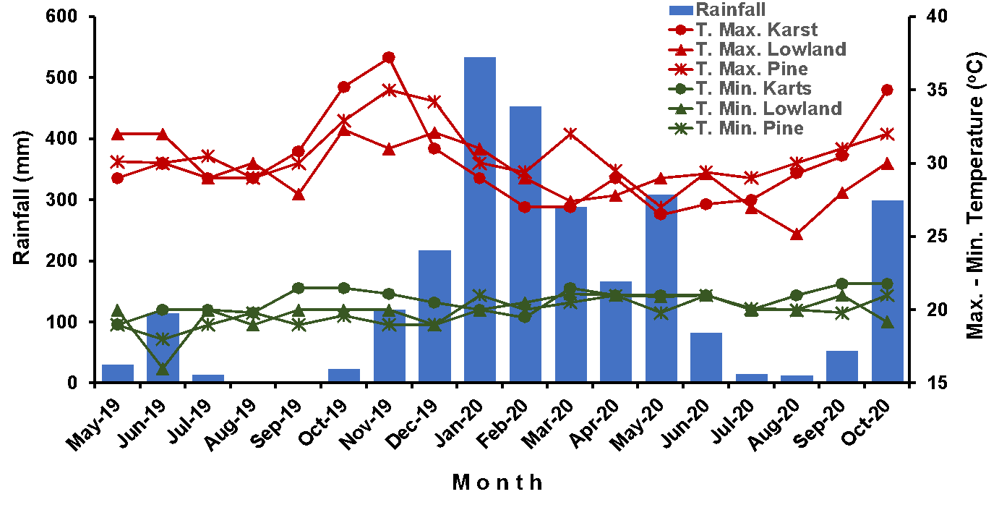
Figure 1. The dynamic of climate elements during the study period (Data for this graph were obtained from the Badan Meteorologi Klimatologi dan Geofisika Republik Indonesia)

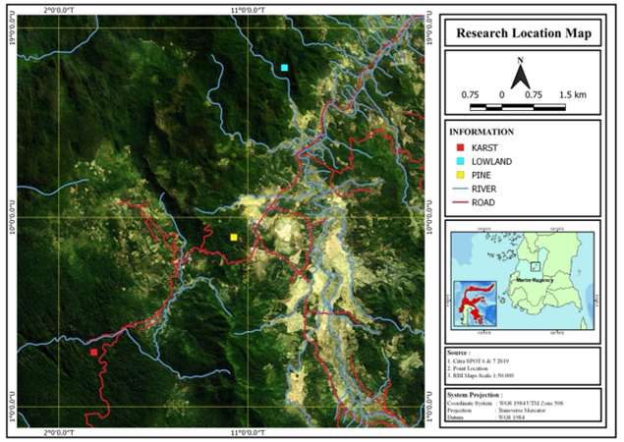
Figure 2. Map showing the locations of the three forest communities studied. This map was produced using QGIS 3.10.9 – A Coruna (A Free and Open Source Geographic Information System) based on three data sources: Citra SPOT 6 & 7 2019, Point location (measured using Garmin GPSMAP 60CSx), and RBI map 1 : 50000

DISCUSSION (SECTION)
Discussion should be concise and focused on the interpretation of the results, not repeat the results. The author should be able to emphasize the main findings and show the novelty of the work. The author should provide a concise explanation of the implications of the findings, particularly in relation to previous related studies and potential future directions for research. All cited studies must be from peer-reviewed articles.

ACKNOWLEDGMENT (SECTION)
Acknowledgment should be brief with essential credit, especially for the funding source who supports the research and those who help during the research and writing and checking the manuscript (providing English editing, writing assistance, proofreading the manuscript, etc.).

FUNDING STATEMENT (SECTION)
As part of the journal’s updated policies, all authors must now state how the research and publication of their article were funded, by naming financially supporting body(s) (written out in full) followed by associated grant number(s) in square brackets (if applicable), for example: “This work was supported by the Engineering and Physical Sciences Research Council [grant numbers xxxx, yyyy]; the National Science Foundation [grant number zzzz]; and a Leverhulme Trust Research Project Grant”. If the research did not receive specific funding but was performed as part of the employment of the authors, please name this employer. If the funder was involved in the manuscript writing, editing, approval, or decision to publish, please declare this.

AUTHOR CONTRIBUTIONS (SECTION)
Articles with more than one author must include each author’s contribution. The writing of “main contributors” and/or “member contributors” is written in this section. The author's names are arranged sequentially according to what is contained on the title page, and only the first name and last name are written (eg “Putu Ngakan” for “Putu Oka Ngakan”),. Examples: Putu Ngakan: research conceptualization, research coordinator, data analysis, data interpretation, manuscript writing; Nasri Nasri: member contributor, research implementer, interpretation, manuscript writing; Andi Hamzah: member contributor, research implementer, map making, manuscript writing”.

CONFLICTS OF INTEREST (SECTION)
Authors must declare all relevant interests that could be perceived as conflicting. Authors should explain why each interest may represent a conflict. If no conflicts exist, the authors should state this. Submitting authors are responsible for co-authors declaring their interests.

REFERENCES (SECTION)
Please ensure that every reference cited in the text is also present in the reference list (vice versa). We encourage using primary source references published within ten years. American Physiological Association (APA) 7th edition is used as a reference style. Cite references in the text in alphabetical order first and chronological order second.
JPK Wallacea encourages author(s) to use reference management software such as Mendeley, Zotero, as well as EndNote and select the APA 7th edition style template when preparing the article using the word processor such as Microsoft Office Word. Please refer to the Author's Guide for details
Example:
Journal
Morris, R,J. (2010). Anthropogenic impacts on tropical forest biodiversity: a network structure and ecosystem functioning perspective. Philosophical Transactions of the Royal Society B: Biological Sciences, 365(1558), 3709-3718. https://doi.org/10.1098/rstb.2010.0273
Berg, B., & Meentemeyer, V. (2001). Litter fall in some European coniferous forests as dependent on climate: a synthesis. Canadian Journal of Forest Research, 31(2), 292-301. https://doi.org/10.1139/cjfr-31-2-292.
Nanda, A., Suresh, H.S., & Krishnamurthy, Y.L. (2014). Phenology of a tropical dry deciduous forest of Bhadra wildlife sanctuary, southern India. Ecological Processes, 3(1), 1-12. https://doi.org/10.1186/2192-1709-3-1.
Rungrojtrakool, P., Tiansawat, P., Jampeetong, A., Shannon, D.P., & Chairuangsri, S. (2021). Soil seed banks of tree species from natural forests, restoration sites, and abandoned areas in Chiang Mai, Thailand. Forest and Society, 5(1), 167-180. https://doi.org/10.24259/fs.v5i1.11612.

Book:
Whitmore TC (1986) Tropical Rain Forests of the Far East, 2nd Edition. Oxford University Press, Clarendon, Oxford, UK. p. 243.

Chapter in an Edited Book:
Hanson KT, Kristen S. Morrow KS, Ngakan PO, Trinidad JS, Zak AA, and Riley EP (2022) Encountering Sulawesi’s endemic primates: Considerations for developing primate tourism in South Sulawesi, Indonesia. In SL Gursky, J Supriatna, A. Achor (Eds.), Ecotourism and Indonesia’s Primates (pp. 111-151). Springer. https://doi.org/10.1007/978-3-031-14919-1_7.
Berjak, P., & Pammenter, N,W. (2017). Recalcitrance. Encyclopedia of Applied Plant Sciences (Second Edition). University of KwaZulu-Natal, Durban, South Africa. 532-539. https://doi.org/10.1016/B978-0-12-394807-6.00048-4.

Unpublished Works:
Putra, P.S., Achmad, A., Yamada, T,, & Ngakan, P.O. (2023). Seasonal litter production patterns in three tropical forests in Sulawesi, Indonesia: Implications for managing secondary forests. Biodiversitas, 24 (In press).

Book chapters
Regulations:
Departemen Kehutanan (2004). Peraturan Menteri Kehutanan Nomor: P.01/Menhut-11/2004 tentang Pemberdayaan Masyarakat Setempat di Dalam dan atau di Sekitar Hutan dalam Rangka Social Forestry. Jakarta: Biro Hukum dan Organisasi Dephut.
Lembaga Ilmu Pengetahuan Indonesia (2012). Peraturan Kepala Lembaga Ilmu Pengetahuan Indonesia Nomor: 04/E/2012 tentang Pedoman Karya Tulis Ilmiah. Jakarta: LIPI.

Proceedings article:
Rahajoe, J. S., Susanti, R., & Simbolon, H. (2021 May). Decomposition rate of some dominant tree species in low montane forest of Gunung Halimun Salak National Park, West Java-Indonesia. IOP Conf. Series: Earth and Environmental Science, 762(1), 012010. https://doi.org/10.1088/1755-1315/762/1/012010.

Websites:
Samsoedin, Kartawinata, K., & Sugiarti, H. (2011). Ex-situ Conservation of Plants Species in Wallacea. Lembaga Ilmu Pengetahuan Indonesia. Retrieved from http://lipi.go.id/publikasi/ex-situ-conservation-of-plants-species-in-wallacea/6918. 13 February 2023

---------------*****--------------

Please do not alter the formatting and layouts style which have been set up in this template document.
This template is available for use and checks as a requirement at the time of article submission.

Delete after writing a manuscript (Red writing above and anything else that is not needed)

